 

INSTITUTE FOR ADVANCED COMPUTING AND SOFTWARE DEVELOPMENT AKURDI, PUNE

Documentation On

Book-Store Inventory System

PG-DAC March 2022

**Submitted By:**

**Group No: 23**

**Roll No. Name:**

**223032 Shahabaz Bagwan**

**223119 Shubham Nalawade**

**Mr. Prashant Karhale Mrs.Megha S. Mane**

**Centre Coordinator Mrs.Sonali A. Mogal**

**Project Guide**

# ABSTRACT

This project is a web-based inventory system for an existing store. The main objective of the project is to create a Bookstore Inventory System that allows users(manager) to add, remove, update and search a book based on name of book, author, etc. The selected books are displayed in a tabular format and the user search the books. Using this system the user can manage the books properly in book store.

Bookstore is the place where the people will be able to get the books of their choice at reasonable price. There can be various kinds of books available at the book store. But if it is the giant bookstore then the management of it will be very difficult. The software system being produced is called Book Store Inventory System. It is being produced for a maintaining inventory details of books in bookstore via the Internet.

# ACKNOWLEDGEMENT

I take this occasion to thank God, almighty for blessing us with his grace and taking our endeavor to a successful culmination. I extend my sincere and heartfelt thanks to our esteemed guide, **Mrs.Megha S. Mane & Mrs.Sonali A. Mogal** for providing me with the right guidance and advice at the crucial juncture sand for showing me the right way. I extend my sincere thanks to our respected **Centre Co-Ordinator Mr. Prashant Karhale**, for allowing us to use the facilities available. I would like to thank the other faculty members also, at this occasion. Last but not the least, I would like to thank my friends and family for the support and encouragement they have given me during the course of our work.

**Shahabaz Bagwan (223032)**

**Shubham Nalawade (223119)**

**Table of Contents**

ABSTRACT 2

ACKNOWLEDGEMENT 3

INTRODUCTION 7

* 1. PROJECT OBJECTIVE 8
  2. PROJECT OVERVIEW 8
  3. PROJECT SCOPE 9
  4. STUDY OF THE SYSTEM 9
     1. MODULES 9

SYSTEM ANALYSIS 12

* 1. EXISTING SYSTEM 12
  2. PROPOSED SYSTEM 12
  3. SYSTEM REQUIREMENT SPECIFICATION 13
     1. GENERAL DESCRIPTION 13
     2. SYSTEM REQUIREMENTS 13

ADMIN 14

MANAGER 14

SYSTEM DESIGN 15

* 1. INPUT AND OUTPUT DESIGN 15
     1. INPUT DESIGN 15
     2. OUTPUT DESIGN 16

DATABASE DESIGN 17

* 1. DATABASE 17
  2. SYSTEM TOOLS 17
     1. FRONT END 17
     2. BACKEND 17

1 LEVEL DFD FOR USER LOGIN 19

1. LEVEL DFD FOR BOOK MANAGEMENT 20

1 LEVEL DFD FOR BOOK SEARCH MANAGEMENT 21

E-R DIAGRAM 22

USE CASE DIAGRAM ADMIN 23

USE CASE DIAGRAM MANAGER 24

TABLE STRUCTURE 25

PROJECT DIAGRAMS 26

CONCLUSION 35

REFERENCES 36

**LIST OF FIGURES**

**FIGURE 1: ADMIN ACTIVITY DIAGRAM 10**

**FIGURE 2: MANAGER ACTIVITY DIAGRAM 11**

**FIGURE 3: 1 LEVEL DFD FOR USER LOGIN 19**

**FIGURE 4: 1 LEVEL DFD FOR BOOK MANAGEMENT 20**

**FIGURE 5: 1 LEVEL DFD FOR BOOK SEARCH MANAGEMENT 21**

**FIGURE 6: E-R DIAGRAM 22**

**FIGURE 7: USE CASE DIAGRAM ADMIN 23**

**FIGURE 8: USE CASE DIAGRAM MANAGER 24**

**FIGURE 9: TABLE STRUCTURE 25**

**FIGURE 10: PROJECT DIAGRAMS 26**

# INTRODUCTION

Bookstore is the place where the people will be able to get the books of their choice at reasonable price. There can be various kinds of books available at the book store. But if it is the giant bookstore then the management of it will be very difficult. The software system being produced is called Book Store Inventory System. It is being produced for a maintaining inventory detail of books in bookstore via the Internet. The Book Store Inventory System will allow admin user to add Book Store Manager and also it will allow Manager to manage Inventory.

This project is a web-based inventory system for an existing store. The Bookstore Inventory System where the admin can Add, Update and remove Manager. A user(manager) can select a particular book to view the details through searching book.

The system also allows a manager to manage the inventory with full create, retrieve, update and delete functionality with regards to books in the system. The objective of the project is to make an application in android platform to manage books in an existing store. In order to build such an application complete web support, need to be provided. A complete and efficient web application which can provide the bookstore inventory system experience is the basic objective of the project. The web application can be implemented in the form of an android application with web view.

**Features:** -

1. Books Available-Wings of fire, Head first Java, You can win etc.
2. Search for Books in list.
3. The admin can add/delete/edit Managers.
4. Allows the manager to search/add/remove/update books.
   1. **PROJECT OBJECTIVE**

The objective of the project is to make an inventory system to managing items in an existing book-store. In order to build such an application complete web support, need to be provided. A complete and efficient web application which can provide the suitable experience for handling inventory of store. The web application can be implemented in the form of an android application with web view.

* 1. **PROJECT OVERVIEW**

The central concept of the application is to allow the user to manage inventory virtually using the internet. The information pertaining to the books-store are stores on an RDBMS at the server side.

The application was designed into two modules first is for the admin who can manages the working managers into the book-store. Second is for the book-store manager who maintains the inventory stock of books in the store. And after adding or removing stock from the inventory he/she can updates the inventory according to it. The application is hosted on the web and the administrator maintains the database. The application, which is deploy the book-store database, the details of the books are brought forward from the database for the manager view based on the selection through the UI and the database is updated at the end of each transaction. Data entry into the application can be done through various screens designed for various levels of users. Once the authorized person feed the relevant data into the system, he/she can directed to desired page.

* 1. **PROJECT SCOPE**

This system can be implemented to any shop in the locality or to multinational branded shops

having retail outlet chains. By using this system, we can get rid from traditional method of maintaining records of stocks in inventory in register or somewhere else manually.

* 1. **STUDY OF THE SYSTEM**

## MODULES:

The system after careful analysis has been identified to be presented with the following modules and roles.

The modules involved are:

* + - * Administrator
      * Manager
      1. Administrator:

The administrator is the super user of this application. Only admin have access into this admin page. Admin may be the owner of the shop. The administrator has all the information about the users.

This module is divided into different sub modules.

* + - * 1. Add Manager
        2. Remove Manager
        3. Edit Manager Info

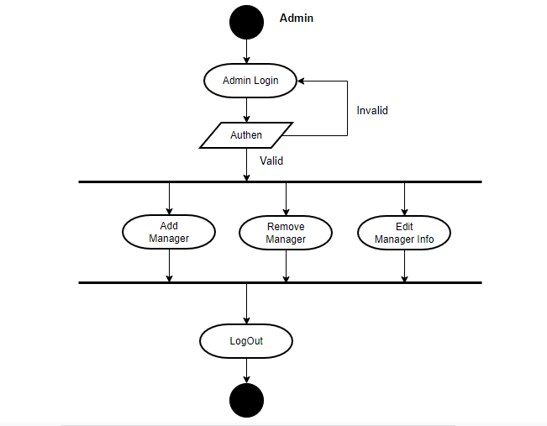

*Figure 1 Admin Activity Diagram*

* **Add Manager**

Administrator can add managers working into the book-store.

* **Remove Manager**

Administrator can delete the managers working into the book-store.

* **Edit Manager Info**

Administrator can update the information related to the managers.

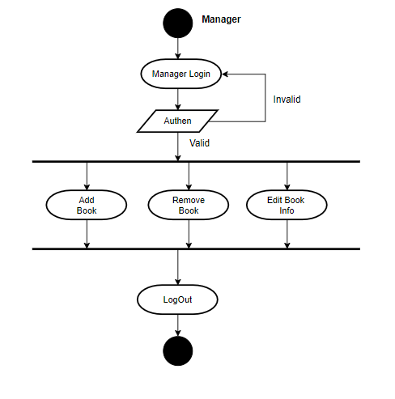

*Figure 2 Manager Activity Diagram*

* **Add Book**

Manager can add books into the inventory.

* **Remove Book**

Manager can remove books into the inventory.

* **Edit book Info**

Manager can edit information related to books into the inventory.

**SYSTEM ANALYSIS**

System analysis is the process of gathering and interpreting facts, diagnosing problems, and using the information to recommend improvements on the system. System analysis is a problem-solving activity that requires intensive communication between the system users and system developers.

System analysis or study is an important phase of any system development process. The system is viewed as a whole, the inputs are identified, and the system is subjected to close study to identify the problem areas. The solutions are given as a proposal. The proposal is reviewed on user request and suitable changes are made. This loop ends as soon as the user is satisfied with the proposal.

* 1. **EXISTING SYSTEM**

The current system for maintaining the inventory of book-store is by using pen and paper method. Where all records are written in some notebook or register.

* + - It is less user-friendly.
    - User must do all things themselves.
    - It is difficult to identify the actual stock present in inventory.
    - It is a time-consuming process
    - It required more precision.
  1. **PROPOSED SYSTEM**

In the proposed system user can maintain inventory virtually by using internet. Administrator can have all control over system. He/she can manage the all the working managers into the book-store. And also, he/she can add, remove, update managers info according to need. Further manager can manage inventory so easily. Managers can update records after the buying new stock and also, he can update records after books are sold from the book-store.

* 1. **SYSTEM REQUIREMENT SPECIFICATION**
     1. **GENERAL DESCRIPTION Product Description:**

The system consists of two parts. A web application which can provide privilege to manages the inventory of book-store. Web application should be able to help the store owner(admin) for maintaining the record of managers working in book-store and to help the managers in managing the inventory.

**Problem Statement:**

Now a days everything is becoming online, because it makes things simpler for us. In our case inventory is managed by using pen and paper method. Which is not safe and also hectic job to maintaining large number of records. So to reduce the efforts and maintain the all inventory records safe at a single place we developed this system .

* + 1. **SYSTEM REQUIREMENTS**
       1. **NON-FUNCTIONAL REQUIREMENTS**
          1. **EFFICIENCY REQUIREMENT**

When a user tries to use system, he/she can able to use it in efficient manner.

* + - * 1. **RELIABILITY REQUIREMENT**

The system should provide a reliable environment to both admin and manager. All details should be reaching at the admin without any errors.

* + - * 1. **USABILITY REQUIREMENT**

The Web application is designed for user friendly environment and ease of use.

* + - * 1. **IMPLEMENTATION REQUIREMENT**

Implementation of the system using React in front end with Spring Boot as back end and it will be used for database connectivity. And the database part is developed by MySQL. Responsive web designing is used for making the website compatible for any type of screen.

* + - 1. **FUNCTIONAL REQUIREMENTS**

**USER**

* **USER LOGIN**

This feature used by the user to login into system. A user must login with his email-Id and password to the system. If they are invalid, the user not allowed to enter the system.

**Functional Requirement**

* Email-Id and password
* Password should be hidden from others while typing it in the field

**ADMIN**

**Description of features**

The administrator can add manager, delete manager, view manager list working in book-store

and update information related to manager.

**MANAGER**

**Description of features**

The manager can add books, delete books, search books and also update the details of books.

# SYSTEM DESIGN

System design is the solution for the creation of a new system. This phase focuses on the detailed implementation of the feasible system. Its emphasis on translating design. Specifications to performance specification. System design has two phases of development.

* Logical Design
* Physical Design

During logical design phase the analyst describes inputs (sources), outputs(destinations), databases (data sores) and procedures (data flows) all in a format that meets the user requirements. The analyst also specifies the needs of the user at a level that virtually determines the information flow in and out of the system and the data resources. Here the logical design is done through data flow diagrams and database design. The physical design is followed by physical design or coding. Physical design produces the working system by defining the design specifications, which specify exactly what the candidate system must do. The programmers write the necessary programs that accept input from the user, perform necessary processing on accepted data and produce the required report on a hard copy or display it on the screen.

* 1. **INPUT AND OUTPUT DESIGN**
     1. **INPUT DESIGN:**

Input design is the link that ties the information system into the world of its users. The input design involves determining the inputs, validating the data, minimizing the data entry and provides a multi-user facility. Inaccurate inputs are the most common cause of errors in data processing. Errors entered by the data entry operators can be controlled by input design. The user-originated inputs are converted to a computer-based format in the input design. Input data are collected and organized into groups of similar data. Once identified, the appropriate input media are selected for processing. All the input data are validated and if any data violates any conditions, the user is warned by a message. If the data satisfies all the conditions, it is transferred to the appropriate tables in the database. In this project the student details are to be entered at the time of registration. A page is designed for this purpose which is user friendly and easy to use. The design is done such that users get appropriate messages when exceptions occur.

* + 1. **OUTPUT DESIGN:**

Computer output is the most important and direct source of information to the user. Output design

is a very important phase since the output needs to be in an efficient manner.

Efficient and intelligible output design improves the system relationship with the user and helps

in decision making. Allowing the user to view the sample screen is important because the

user is the ultimate judge of the quality of output. The output module of this system is the

selected notifications.

# DATABASE DESIGN

* 1. **DATABASE**

Databases are the storehouses of data used in the software systems. The data is stored in tables inside the database. Several tables are created for the manipulation of the data for the system. Two essential settings for a database are

* Primary key - the field that is unique for all the record occurrences
* Foreign key - the field used to set relation between tables Normalization is a technique to avoid redundancy in the tables.
  1. **SYSTEM TOOLS**

The various system tools that have been used in developing both the front end and the back end of the project are being discussed in this chapter.

* + 1. **FRONT END:**

React is a library which is developed by Facebook are utilized to implement the frontend. React (also known as React.js or ReactJS) is a [free and open-source](https://en.wikipedia.org/wiki/Free_and_open-source_software) [front-end](https://en.wikipedia.org/wiki/Front_end_and_back_end) [JavaScript](https://en.wikipedia.org/wiki/JavaScript_library) [library](https://en.wikipedia.org/wiki/JavaScript_library) for building [user interfaces](https://en.wikipedia.org/wiki/User_interfaces) or UI components. It is maintained by [Facebook](https://en.wikipedia.org/wiki/Facebook%2C_Inc) and a community of individual developers and companies. React can be used as a base in the development of [single](https://en.wikipedia.org/wiki/Single-page_application) [page](https://en.wikipedia.org/wiki/Single-page_application) or mobile applications. However, React is only concerned with state management and rendering that state to the [DOM,](https://en.wikipedia.org/wiki/Document_Object_Model) so creating React applications usually requires the use of additional libraries for routing, as well as certain client-side functionality.

* + 1. **BACKEND:**

The back end is implemented using MySQL which is used to design databases.

**MySQL:**

MySQL is the world's second most widely used open-source relational database management system (RDBMS). The SQL phrase stands for Structured Query Language. An application software called Navicert was used to design the tables in MySQL.

**Spring-Boot :**

` This is used to connect MYSQL and fetch data from database and store the data in database. The Spring Framework is a[n application framework](https://en.wikipedia.org/wiki/Application_framework) and [inversion of control](https://en.wikipedia.org/wiki/Inversion_of_control) [container](https://en.wikipedia.org/wiki/Servlet_container) for the [Java](https://en.wikipedia.org/wiki/Java_platform) [platform.](https://en.wikipedia.org/wiki/Java_platform) The framework's core features can be used by any Java application, but there are extensions for building web applications on top of the [Java EE](https://en.wikipedia.org/wiki/Java_EE) (Enterprise Edition) platform. Although the framework does not impose any specific [programming model,](https://en.wikipedia.org/wiki/Programming_model) it has become popular in the Java community as an addition to the [Enterprise JavaBeans](https://en.wikipedia.org/wiki/Enterprise_JavaBeans) (EJB) model. The Spring Framework is Open-source Framework.

# 1 Level DFD for User Login

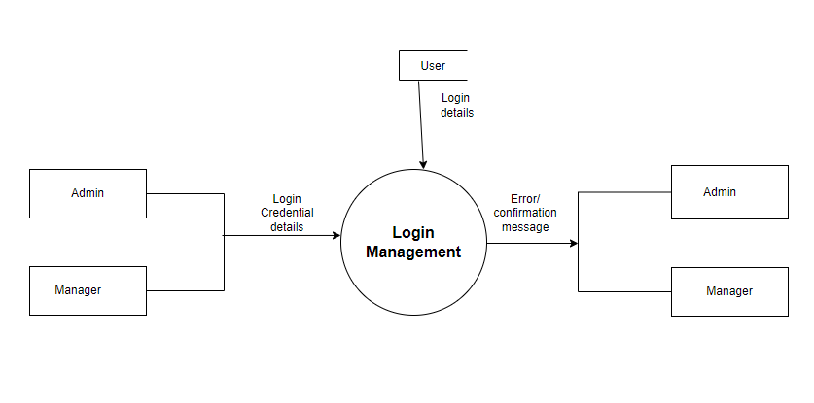

***Figure 3 1 Level DFD for User Login***

# 1 Level DFD for Book Management

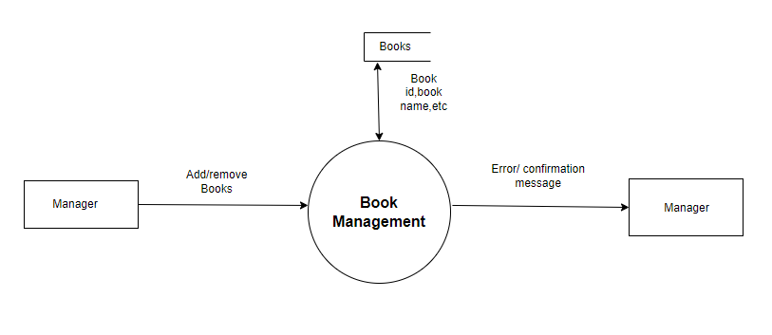

***Figure 4 1 Level DFD for Book Management***

# 1 Level DFD for Book Search Management

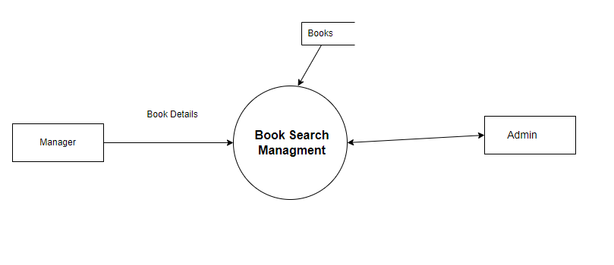

***Figure 5 1 Level DFD for Book Search Management***

# E-R Diagram:

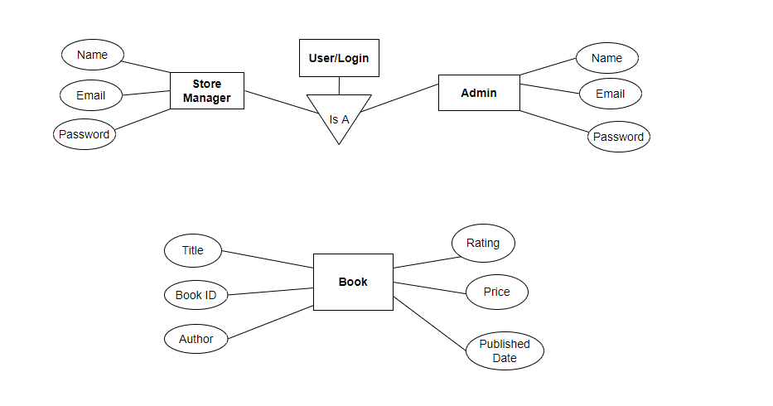

***Figure 6 E-R Diagram***

**Use Case Diagrams :**

**1)Admin :**

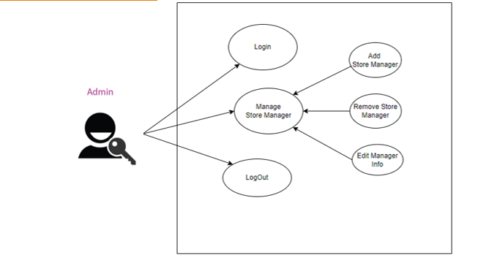

***Figure 7 Use case Diagram Admin***

**2) Manager :**

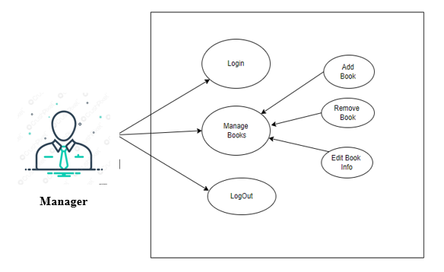

***Figure 8 Use case Diagram Manager***

# TABLE STRUCTURE:

**Tables:**

1. **Books**

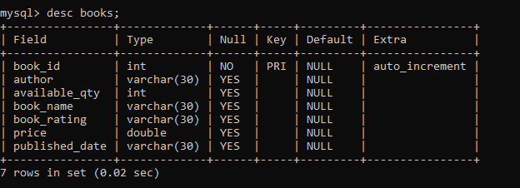

1. **Users**

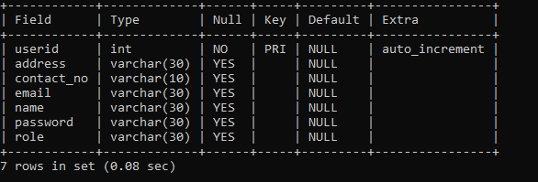

# PROJECT DIAGRAMS

**Home Page :**

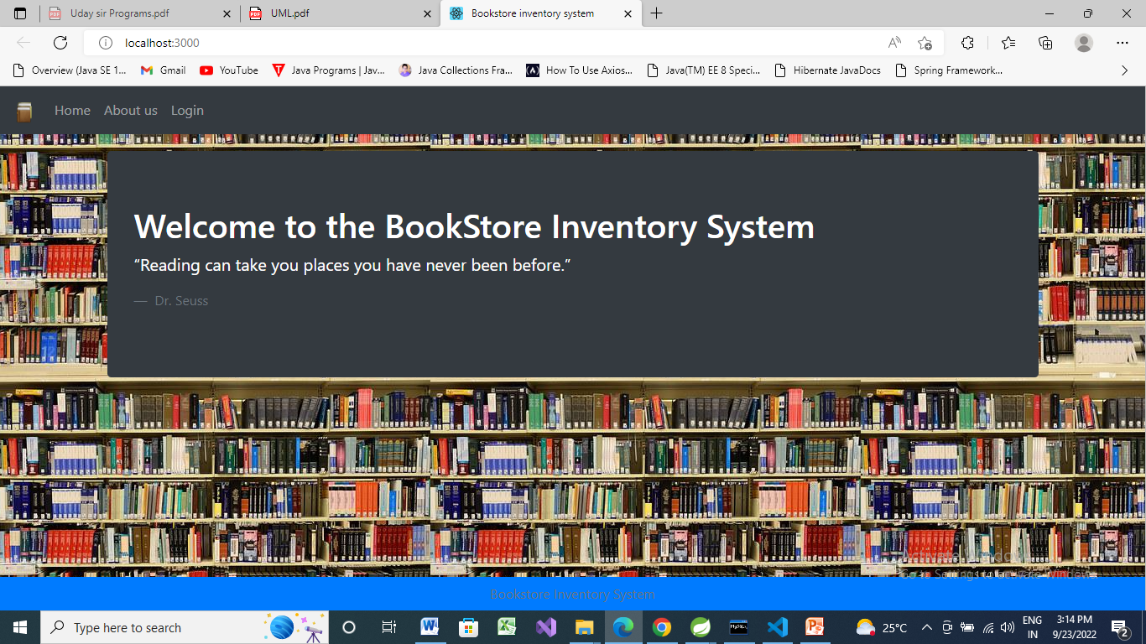

**Login Page :**

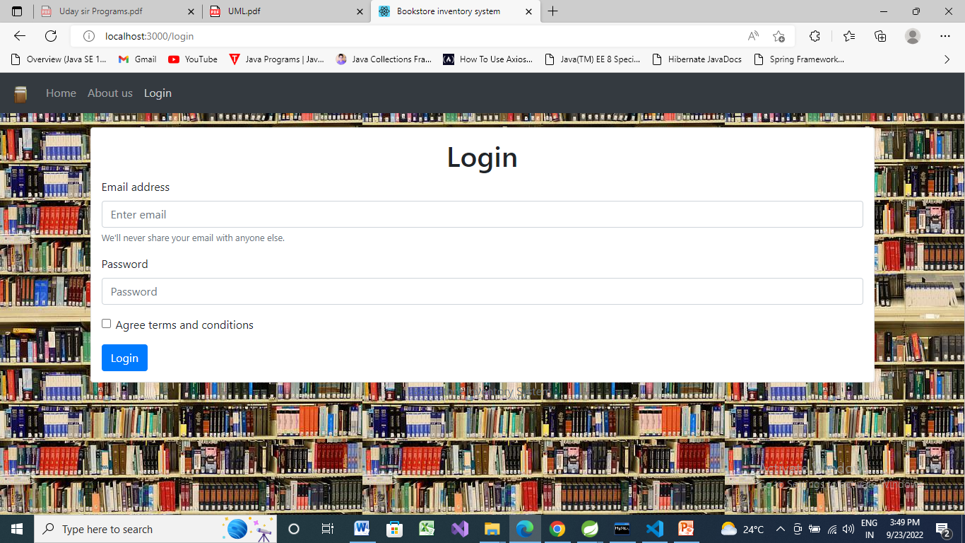

**Invalid Login :**

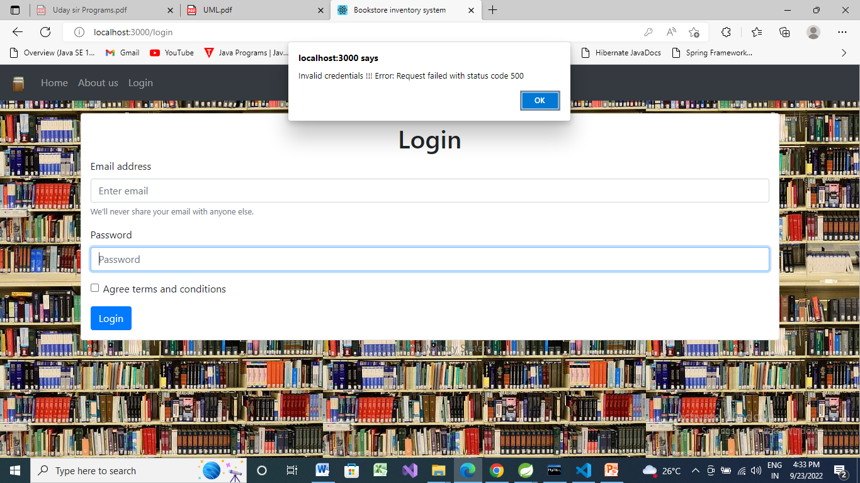

**Successful Login (Admin) :**

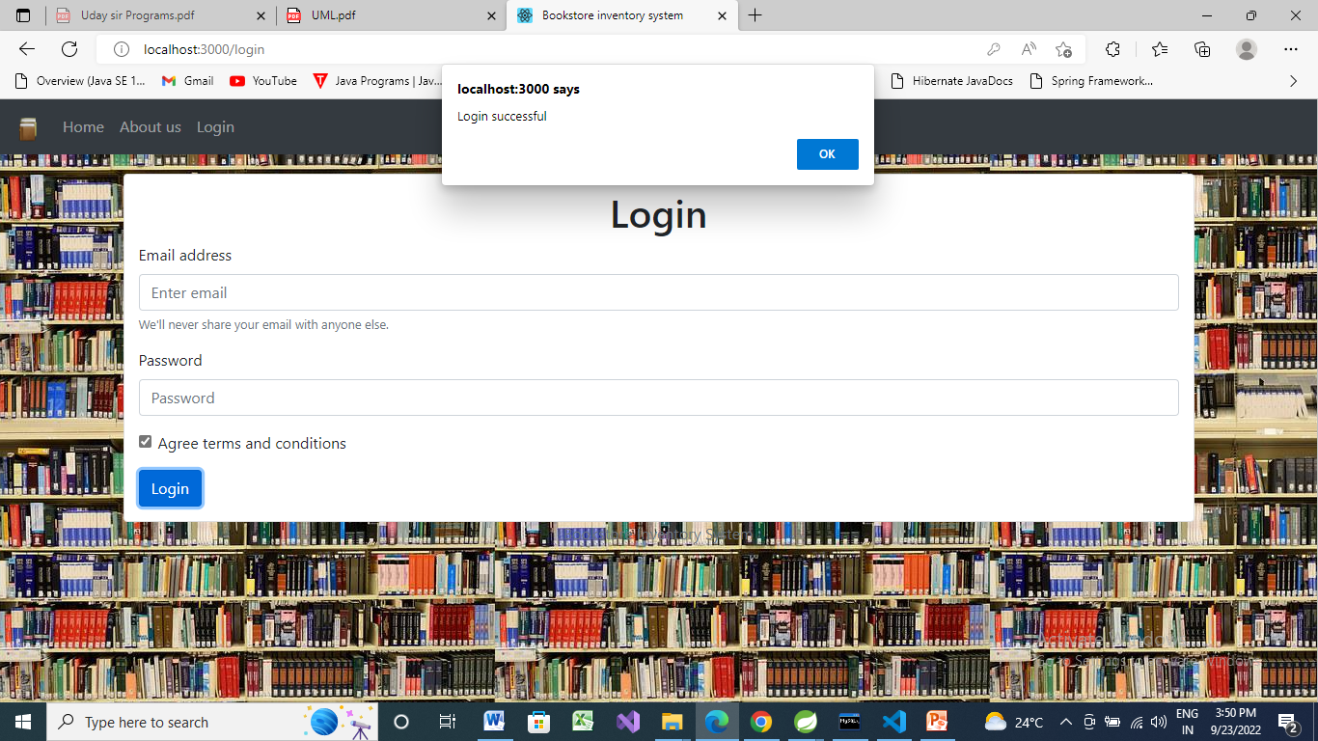

**Admin Page :**

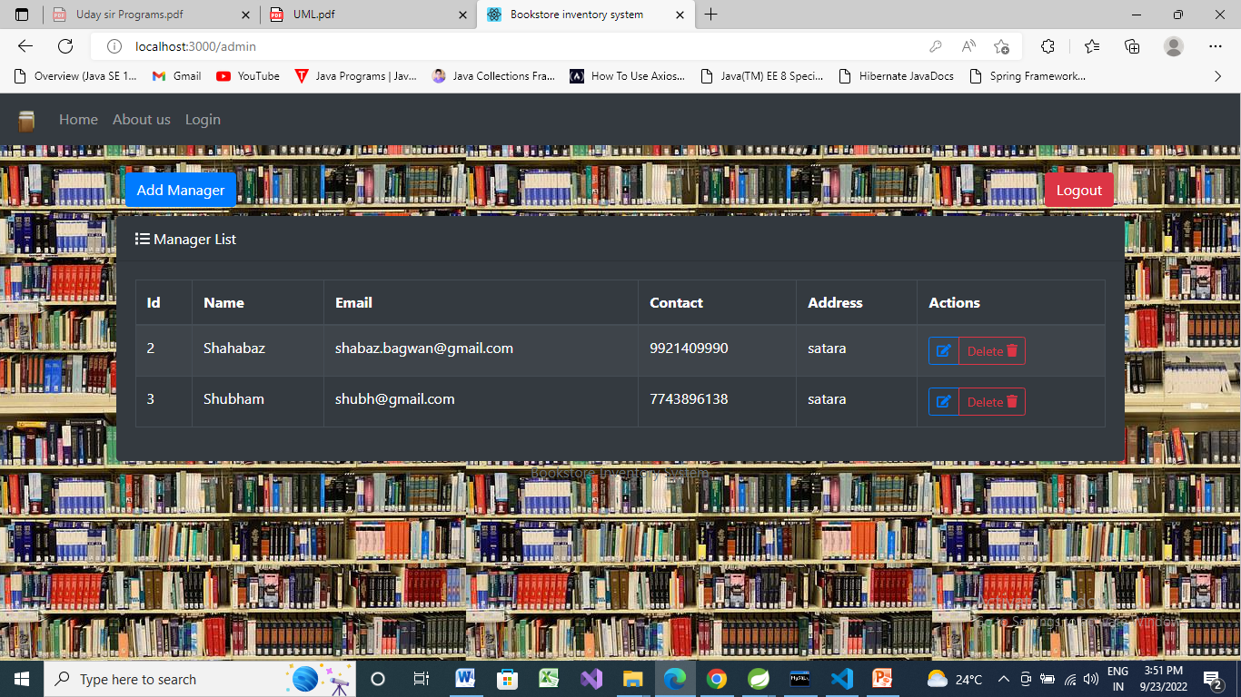

**Add Manager :**

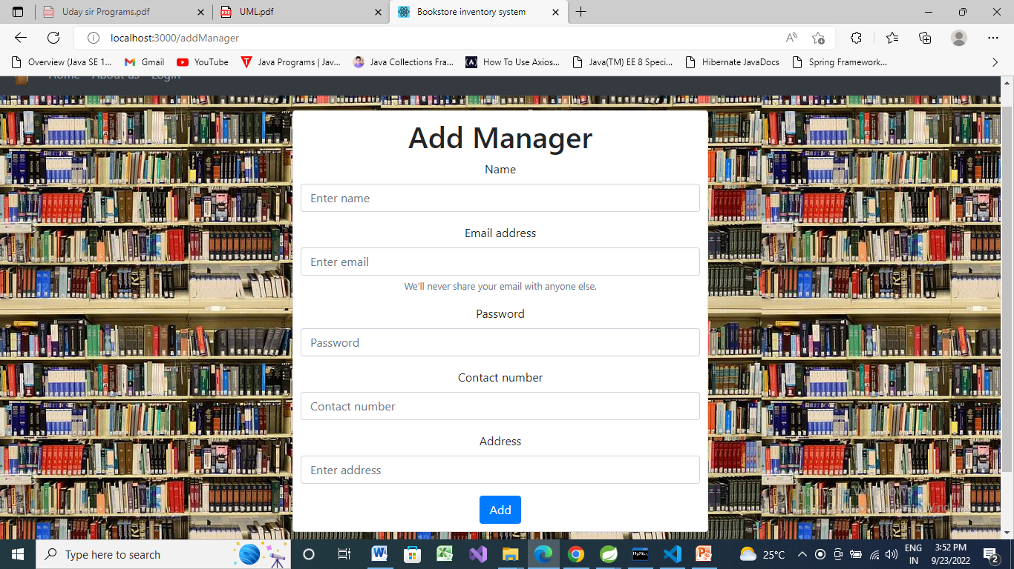

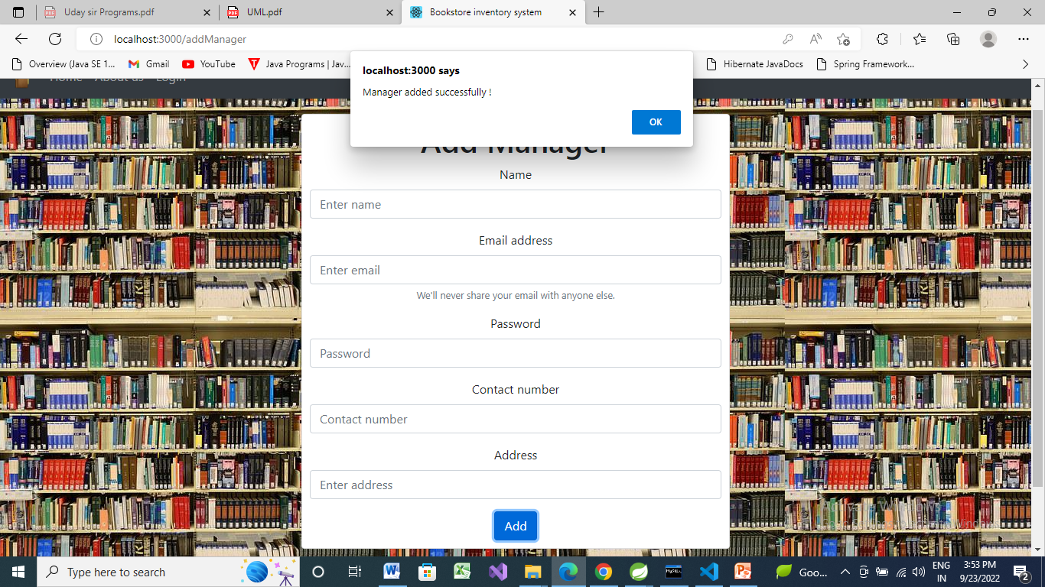

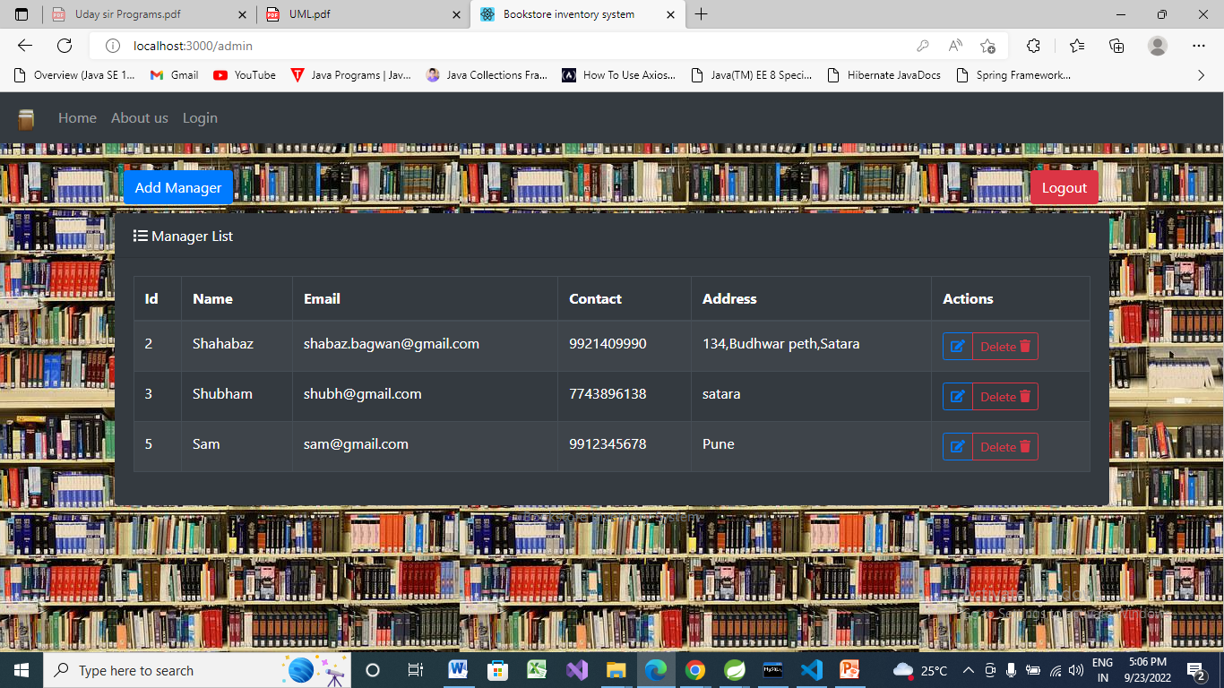

**Update Manager Info :**

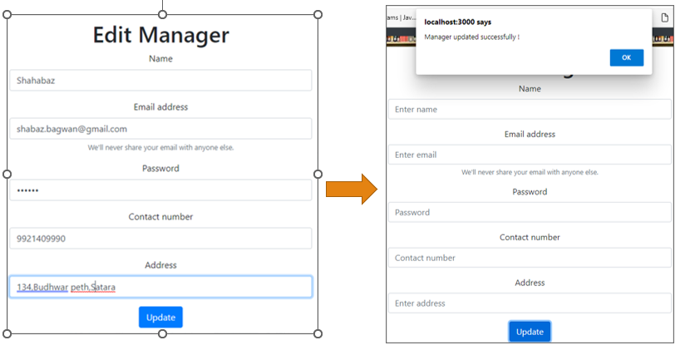

**Delete Manager :**

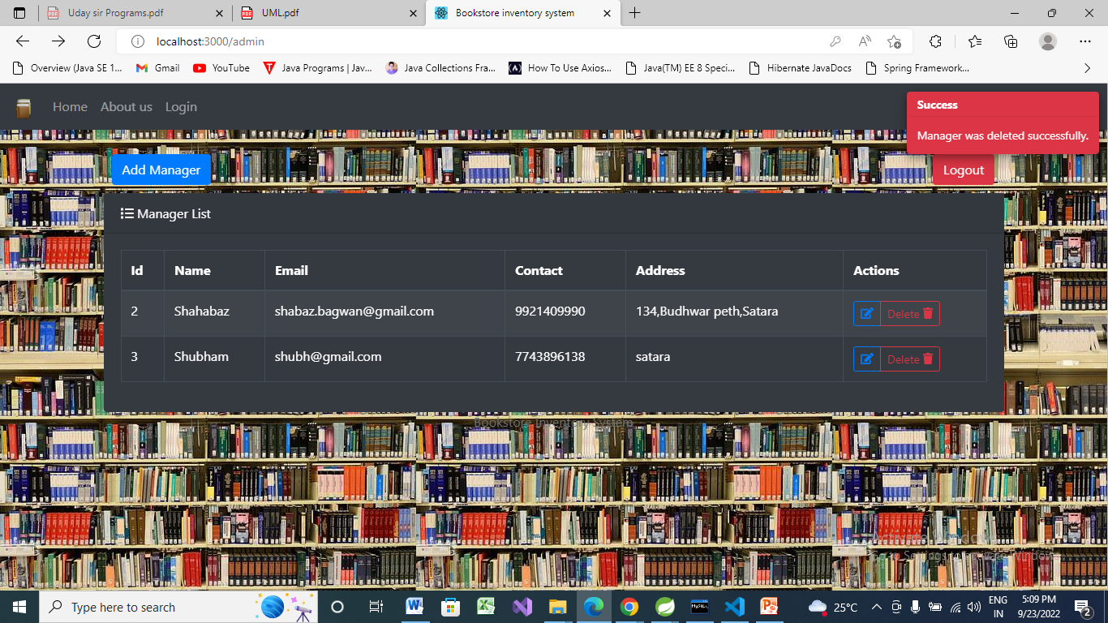

**Manager Login :**

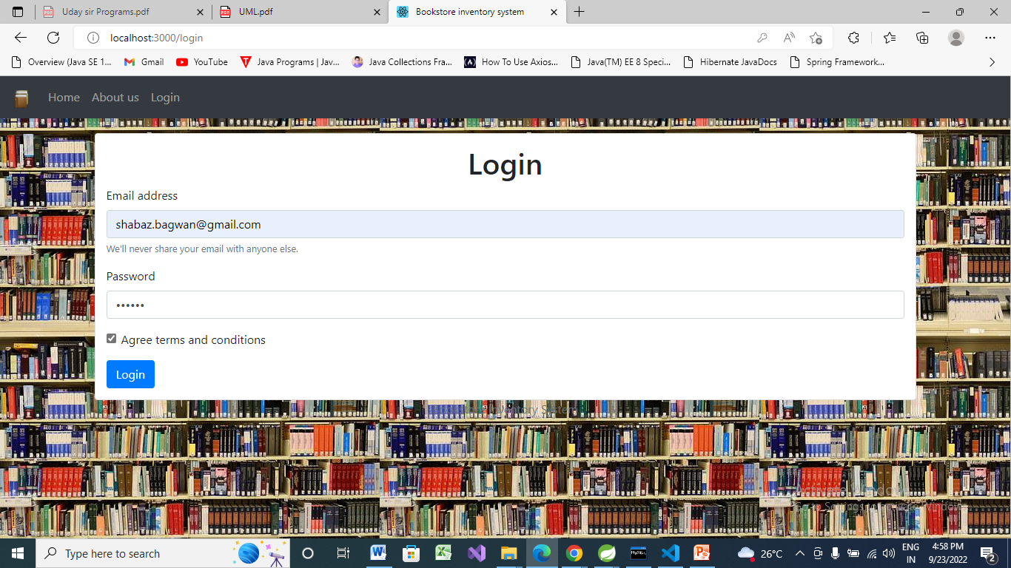

**Manager Page :**

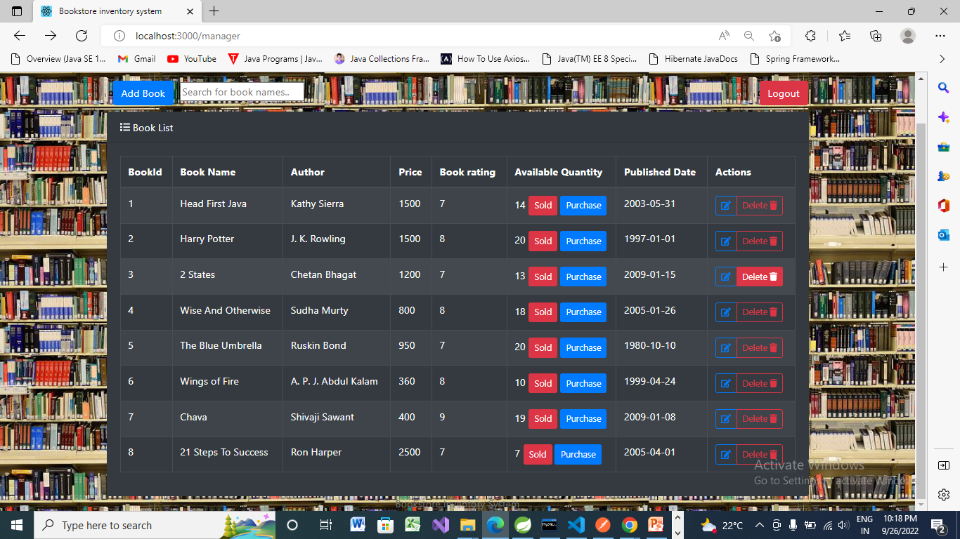

**Add Book :**

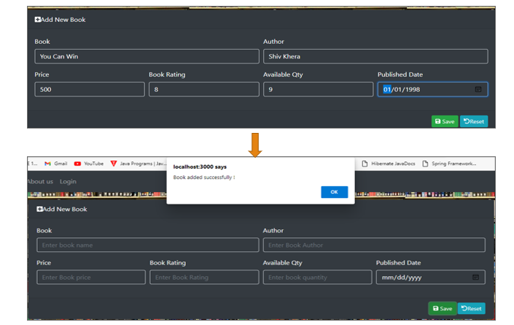

**Update Book :**

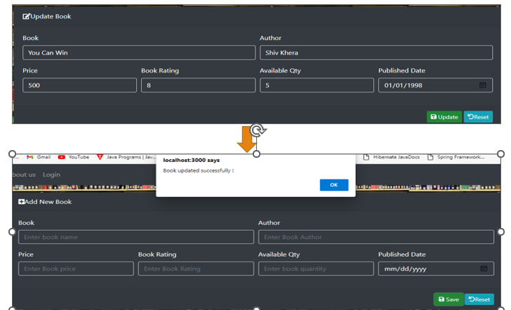

**Delete Book :**

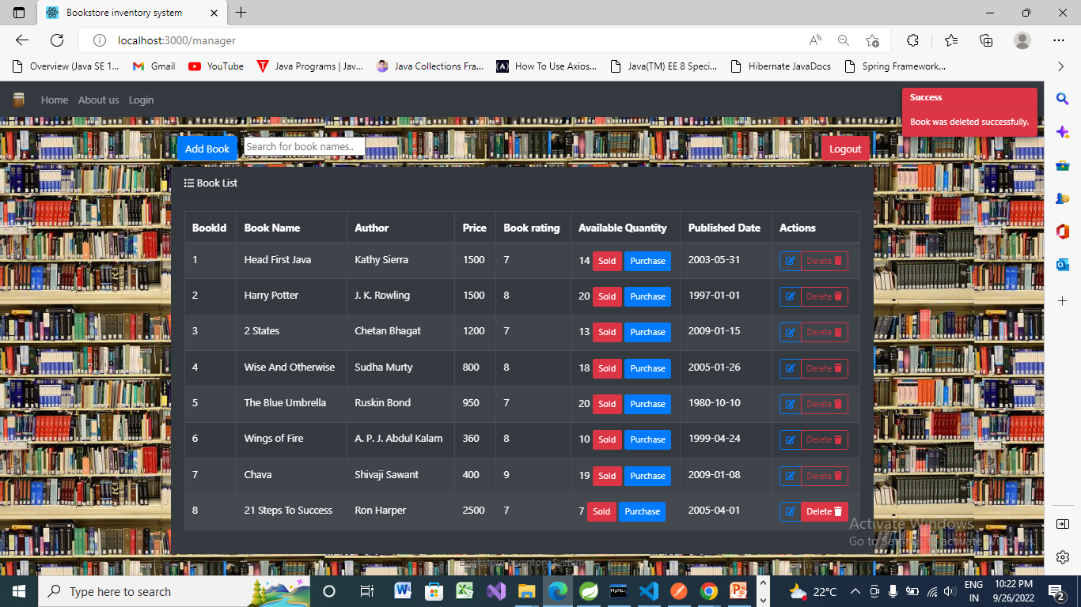

**Quantity reduced :**

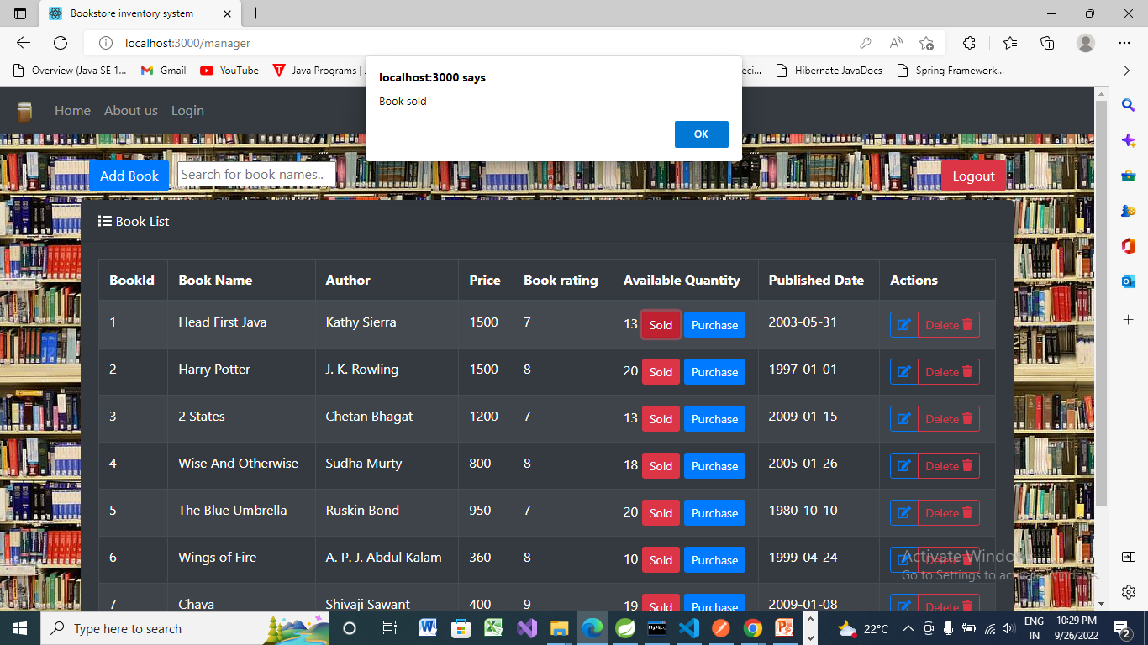

**Quantity Increased:**

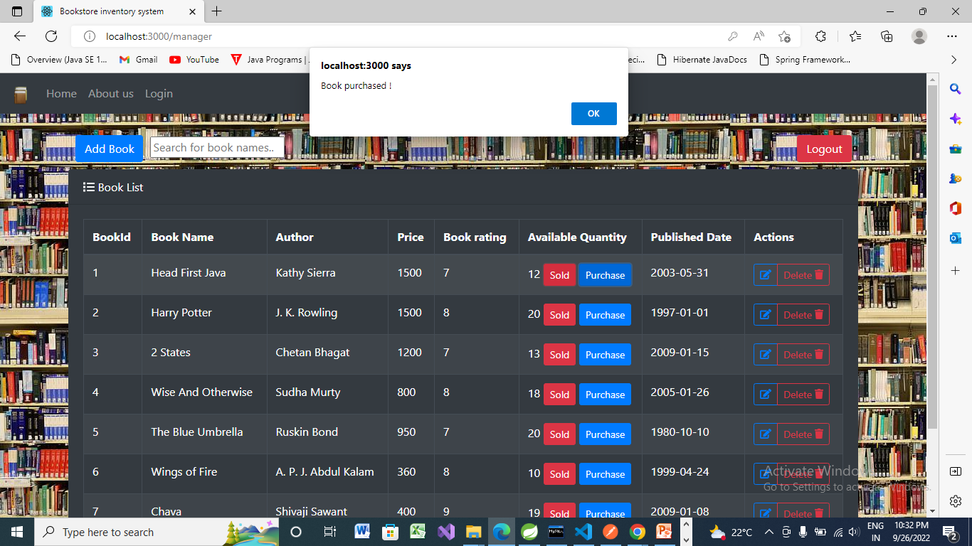

# CONCLUSION

The project entitled **Book-Store Inventory System** was completed successfully.

The system has been developed with much care and free of errors and at the same time it is efficient and less time consuming. The purpose of this project was to develop a web application for managing the book-store inventory.

This project helped us in gaining valuable information and practical knowledge on several topics like designing web pages using React.js, usage of responsive templates, and management of database using MySQL. The entire system is secured. Also, the project helped us understanding about the development phases of a project and software development life cycle. We learned how to test different features of a project.

This project has given us great satisfaction in having designed an application which can be implemented to any nearby book-stores.

There is a scope for further development in our project to a great extent. A number of features can be added to this system in future like adding customer part and maintaining their records. Another feature we wished to implement was providing categories for books so that manager can maintain records according to book categories. After adding customer part system may keep track of history of purchased books by each customer and provide suggestions based on their history. These features could have implemented unless the time did not limit us.

# REFERENCES

1. JavaScript Enlightenment, Cody Lindley-First Edition, based on JavaScript 1.5, ECMA-262,

Edition

1. Mc Graw Hill’s, Java: The complete reference 7thEdition, Herbert Scheldt
2. Complete CSS Guide, Maxine Sherrin and John Allsopp-O'ReillyMedia; September 2012
3. IEEE recommended practice for software requirement specifications-IEEE standard 830-1998.
4. Different documents, registers related to Book-Store Inventory System Project.
5. Object Oriented Software engineering by Yogesh Singh and Ruchika Malhotra, PHI learning private limited-2012.

## ONLINE REFERENCE

* 1. [www.Google.com](http://www.google.com/)
  2. [www.w3school.com](http://www.w3school.com/)
  3. [www.javatpoint.com](http://www.javatpoint.com/)
  4. <https://stackoverflow.com>
  5. https://www.geeksforgeeks.org
  6. https://reactjs.org/docs